**Assignment 2**

**1.Explain the advantages of Natural Queries in Power Bi with an Example ?**

**Ans:** Power BI's Natural Language Query (NLQ) feature allows you to ask questions about your data in plain English and get answers in the form of visualizations, tables, and other insights. This makes it easier for anyone to explore and understand their data, regardless of their technical expertise.

**Why NLQ in Power BI?**

Picture this: you're navigating through your dashboard, and instead of crafting complex queries, you simply type your question into the Q&A box at the top. Power BI, like a wizard, interprets your question and conjures up the most relevant results. It's like having a conversation with your data!

For instance, if you're digging into sales data, try asking:

* What are the total sales for the month of October?
* Which product category had the highest sales last quarter?
* Who are the top 10 customers by sales?

Watch as Power BI automatically generates visualizations and tables, bringing your data to life and revealing trends and patterns in a snap.

**NLQ: Where and How?**

Exciting news – NLQ is at your fingertips across all versions of Power BI, including Power BI Desktop, Power BI Service, and the Power BI mobile app. So, no matter where you are, the power of NLQ is right there with you.

To get started, head to the Q&A box at the top of your dashboards and reports. This feature allows you to ask natural language questions about your data, making exploration seamless, regardless of your technical expertise.

**Real-world Application:**

Let's dive into a practical scenario. Imagine you're a sales manager wanting to analyze monthly performance. With NLQ, you can swiftly ask, "What products contributed most to our sales last month?" – and voila! Instant insights, no SQL expertise required.

**Unlocking the Benefits:**

Why should you embrace NLQ in Power BI? Here are some compelling reasons:

* **Increased Accessibility:** NLQ makes data exploration easy for everyone, regardless of technical expertise.
* **Faster Insights:** Get answers quickly without wrestling with complex queries or custom visualizations.
* **More Natural Interaction:** Speak the language of data in plain English, fostering a more intuitive and engaging experience.

For example, you could ask:

"What were the total sales last quarter?" or "Show me the top 10 customers by revenue."

**2. Explain web Front End (WFE) cluster from Power Bi service Architecture?**

**Ans:**

The Web Front End (WFE) cluster. The WFE cluster manages the initial connection and authentication to the Power BI service. The Web Front End (**WFE**) cluster. The **WFE** cluster manages the initial connection and authentication to the Power BI service.

The **WFE** cluster uses Microsoft Entra ID to authenticate clients, and provide tokens for subsequent client connections to the Power BI service. Power BI uses the **Azure Traffic Manager** (Traffic Manager) to direct user traffic to the nearest datacenter. Traffic Manager directs requests using the DNS record of the client attempting to connect, authenticate, and to download static content and files. Power BI uses the **Azure Content Delivery Network** (CDN) to efficiently distribute the necessary static content and files to users based on geographical locale.

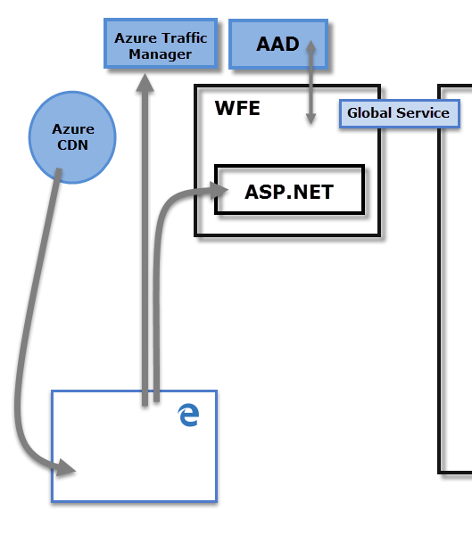

**3.Explain Back End cluster from Power BI Service Architecture ?**

**Ans:** The Back-End cluster. Once authenticated, the Back-End handles all subsequent user interactions.

* The **Back-End** cluster. Once authenticated, the **Back-End** handles all subsequent user interactions. Power BI uses Microsoft Entra ID to store and manage user identities. Microsoft Entra ID also manages data storage and metadata using Azure BLOB and Azure SQL Database, respectively.

The Back-End cluster determines how authenticated clients interact with the Power BI service. The Back-End cluster manages visualizations, user dashboards, semantic models, reports, data storage, data connections, data refresh, and other aspects of interacting with the Power BI service.

The **Back-End** cluster determines how authenticated clients interact with the Power BI service. The **Back-End** cluster manages visualizations, user dashboards, semantic models, reports, data storage, data connections, data refresh, and other aspects of interacting with the Power BI service. The **Gateway Role** acts as a gateway between user requests and the Power BI service. Users don't interact directly with any roles other than the **Gateway Role**. **Azure API Management** eventually handles the **Gateway Role**.

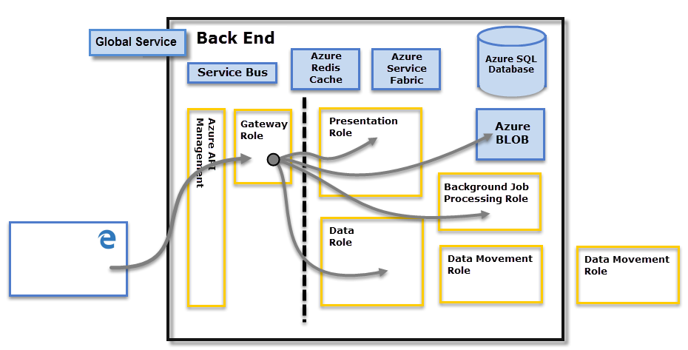

**4.What ASP.NET Component does in Power BI Service Architecture ?**

**Ans:** ASP.NET is an open-source framework that many web developers use to build modern web applications, services and hubs that allow connected clients to access new content in real time. This framework works alongside the hypertext transfer protocol (HTTP), the standard protocol used for all web applications.

**5. Compare Microsoft Excel and Power Bi Desktop on the following festure**

**1)Data Import 2)Data Transformation 3) Modeling 4) Reporting 5) Server Deployement 6)Convert Models 7) Cost**

**Ans:**

### Excel

Enabling and enriched with Intelligence, Excel understands your patterns, organizes your data, and helps in saving you time. Excel provides templates that help you create spreadsheets and perform calculations and modern formulas. Excel will help you to get a better picture of your data. There are wide varieties of charts, graphs, and pictures that help you present your data compellingly with sparklines, formatting, and tables to understand your data better.

### Power BI

Power BI can connect to Excel spreadsheets, cloud, relational databases, NoSQL databases, Data warehouses, flat files, Big Data tools, and more. Power BI is robust, simple, fast, and enterprise-grade, ready for extensive modeling, custom development, and real-time analytics. Power BI is in three forms, for Windows applications, it is Power BI Desktop, as Software as a service (SaaS), it is Power BI service, while third is Power BI apps for phones, tablets, and Android devices.

Key differences between Power BI and Excel

Let us discuss some of the significant differences between Power BI and Excel :

* Power BI is a Business Intelligence (BI) and Data Visualisation tool for creating custom and interactive dashboards from different data sources. At the same time, Microsoft Excel is a software application from Microsoft that is used for data analytics, mathematical operations, data organization, and many more features using a spreadsheet system.
* Power BI is very much faster in processing when comparing Microsoft Excel.
* Power BI can smoothly handle a large amount of data, while Microsoft Excel is limited to some extent of data.
* Power BI handles Big Data, while Microsoft Excel cannot handle Big Data.
* Power BI can connect with different varieties of sources, while Microsoft Excel can connect to limited sources.
* Power BI dashboards are more interactive and custom, while Microsoft Excel dashboards are less interactive.
* Power BI is easy to use and very flexible, while Microsoft Excel is not so handy.
* Power BI is [**mostly used for data visualizations**](https://www.educba.com/careers-in-data-visualization/) and dashboard sharing too many users, while Microsoft Excel is mostly used for in-depth driver analysis.
* Power BI is a more powerful tool comparing Microsoft Excel.
* Power BI is more friendly with mobile devices because of iOS, Android, and Windows apps, while Microsoft Excel is not mobile-friendly.

[**EDUCBA**](https://www.educba.com/)

## Difference Between Power BI vs Excel

Microsoft Excel is an Office 365 product from Microsoft. It was initially released in the year 1985 under Microsoft Corporation, and the current version is Excel 2018. Excel is a type of spreadsheet application that captures data in the form of rows and columns. A recent version of Excel is enriched with various features and applications. You can turn data into insights. Power BI is a business analytics tool from Microsoft. Power BI is a collection of software services, apps, and connectors that combine to turn your unrelated sources of data into interactive insights, coherent and visually immersive insights. Power BI easily connects to different data sources of any size.

### Excel

Enabling and enriched with Intelligence, Excel understands your patterns, organizes your data, and helps in saving you time. Excel provides templates that help you create spreadsheets and perform calculations and modern formulas. Excel will help you to get a better picture of your data. There are wide varieties of charts, graphs, and pictures that help you present your data compellingly with sparklines, formatting, and tables to understand your data better.

### Power BI

Power BI can connect to Excel spreadsheets, cloud, relational databases, NoSQL databases, Data warehouses, flat files, Big Data tools, and more. Power BI is robust, simple, fast, and enterprise-grade, ready for extensive modeling, custom development, and real-time analytics. Power BI is in three forms, for Windows applications, it is Power BI Desktop, as Software as a service (SaaS), it is Power BI service, while third is Power BI apps for phones, tablets, and Android devices.

### Key differences between Power BI and Excel

Let us discuss some of the significant differences between Power BI and Excel :

* Power BI is a Business Intelligence (BI) and Data Visualisation tool for creating custom and interactive dashboards from different data sources. At the same time, Microsoft Excel is a software application from Microsoft that is used for data analytics, mathematical operations, data organization, and many more features using a spreadsheet system.
* Power BI is very much faster in processing when comparing Microsoft Excel.
* Power BI can smoothly handle a large amount of data, while Microsoft Excel is limited to some extent of data.
* Power BI handles Big Data, while Microsoft Excel cannot handle Big Data.
* Power BI can connect with different varieties of sources, while Microsoft Excel can connect to limited sources.
* Power BI dashboards are more interactive and custom, while Microsoft Excel dashboards are less interactive.
* Power BI is easy to use and very flexible, while Microsoft Excel is not so handy.
* Power BI is [**mostly used for data visualizations**](https://www.educba.com/careers-in-data-visualization/) and dashboard sharing too many users, while Microsoft Excel is mostly used for in-depth driver analysis.
* Power BI is a more powerful tool comparing Microsoft Excel.
* Power BI is more friendly with mobile devices because of iOS, Android, and Windows apps, while Microsoft Excel is not mobile-friendly.

### Power BI and Excel Comparison Table

Below is the topmost comparison between Power BI and Excel.

|  |  |  |
| --- | --- | --- |
| **The basis Of Comparison Between Power BI vs Excel** | **Excel** | **Power BI** |
| **Duplicates Table** | Excel tables can show duplicate tables. | Power BI tables cannot show duplicate tables. |
| **Applications** | Excel does have some of the newer charts now; they can’t connect to the data model. | Power BI is ideal for Dashboards, alerts, KPIs, and visualizations, including analyzing your data visually. |
| **Tabular Style** | Excel is better at handling tabular-style reports. | Power BI is not so handy for tabular-style reports. |
| **Reports** | Excel reports are normal and ordinary comparing Power BI. | Power BI offers Beautiful branded reports comparing Excel. |
| **Cross Filtering** | Excel does not advance Cross filtering between charts. | Power BI allows advanced features in Cross filtering between charts. |
| **Dashboard Refreshment** | Excel does not allow dashboard refreshment. | You can refresh data in Power BI. |
| **Analytics** | Excel offers simple analytics compared to Power BI. | Power BI offers High-level analytics. |
| **Reports Availability** | Reports available are limited to specific users. | Reports are available to a broad range of readers with varying degrees of tech-savvy. |
| **Tool** | Excel is your traditional spreadsheet program with a very long history, leading to a vast array of features. | Power BI is an advanced version of the analytics tool with a large number of features to play with data. |
| **Data Model** | Excel is focused on structured and simple[**data models**](https://www.educba.com/data-models-in-dbms/) with a wide range of features. | Power BI focuses on data ingesting and easily building potentially complex data models. |
| **Separate Table** | In Excel, it is difficult to relate the separate table to one another. | In Power BI, you can easily relate separate tables to one another. |
| **Dataset** | Capable of handling a limited dataset. | Capable of handling larger datasets. |
| **Flexible** | Dataset and report are not so flexible. | Sharing data and reports is very flexible. |
| **Dashboard** | A user has limited features to build up reports. | A user can build up a customized dashboard. |
| **Processing Speed** | Speed for processing with table, graph, and filtering is slow. | Faster Processing with table, graph, and filtering. |
| **Requirements** | Excel is mostly used for deep driver analysis. | [**Power BI is mostly used**](https://www.educba.com/power-bi-filter/) for Visualisations and dashboard sharing. |
| **Language Dependency** | MDX language for querying data model. | DAX language for querying data model. |
| **Purpose** | Excel is a historical analytics tool for an analyst. | Power query is a very good idea to simplify the cleaning and crunching of any data source. |
| **Popularity** | Excel applications are a little bit difficult to use comparing Power BI. | Powerful tool and easy to use comparing Excel |

**6.List 20 Data Sources Supported by Power Bi Desktop .**

## Ans: Data sources

The **Get Data** dialog box organizes data types in the following categories:

* All
* File
* Database
* Microsoft Fabric (Preview)
* Power Platform
* Azure
* Online Services
* Other

The **All** category includes all data connection types from all categories.

### File data sources

The **File** category provides the following data connections:

* Excel Workbook
* Text/CSV
* XML
* JSON
* Folder
* PDF
* Parquet
* SharePoint folder

### Database data sources

The **Database** category provides the following data connections:

* SQL Server database
* Access database
* SQL Server Analysis Services database
* Oracle database
* IBM Db2 database
* IBM Informix database (Beta)
* IBM Netezza
* MySQL database
* PostgreSQL database
* Sybase database
* Teradata database
* SAP HANA database
* SAP Business Warehouse Application Server
* SAP Business Warehouse Message Server
* Amazon Redshift
* Impala
* Google BigQuery
* Google BigQuery (Microsoft Entra ID)(Beta)
* Vertica
* Snowflake
* Essbase
* AtScale Models
* Actian (Beta)
* Amazon Athena
* AtScale cubes
* BI Connector
* Data Virtuality LDW
* Denodo
* Exasol
* Indexima
* InterSystems IRIS (Beta)
* Jethro (Beta)
* Kyligence
* Linkar PICK Style / MultiValue Databases (Beta)
* MariaDB
* MarkLogic
* MongoDB Atlas SQL (Beta)
* TIBCO® Data Virtualization
* Dremio Software
* Dremio Cloud